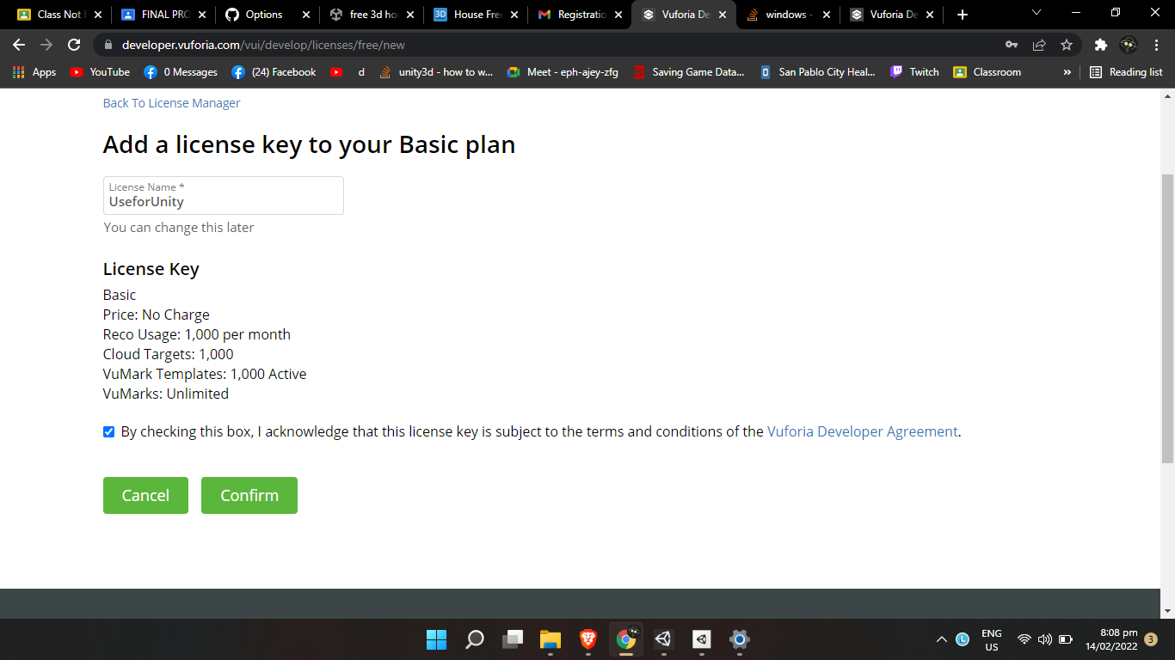

*Figure 1. The Image above is a step were setting up the license key to use in unity, the license is used to enable the use of Vuforia in unity. (The Image above is just one of the steps of setting up Vuforia)*

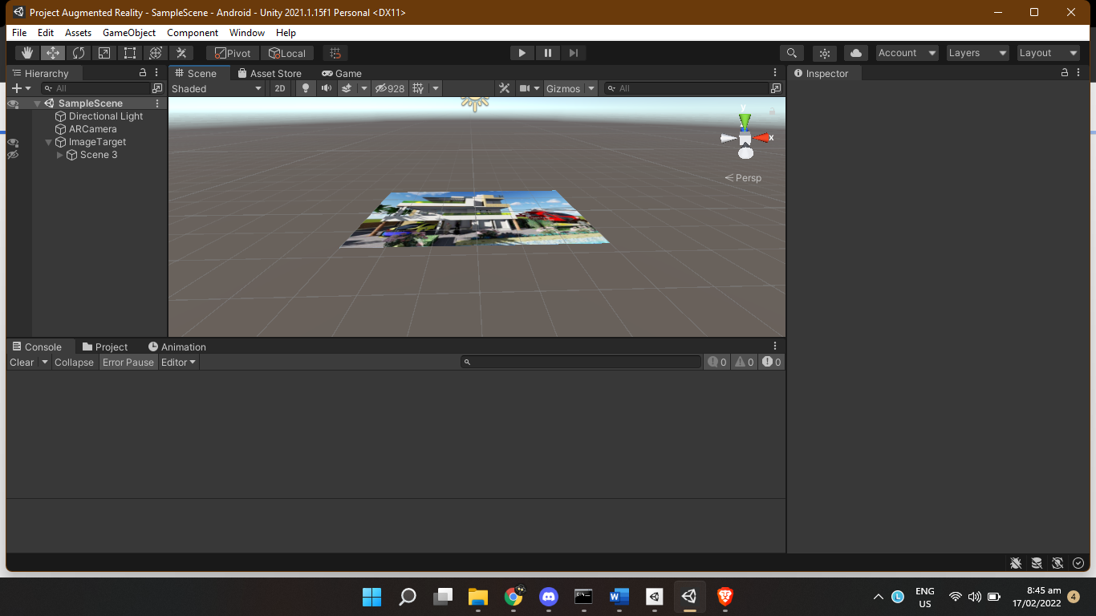

*Figure 2. Setting Up the Image Target (The Image Target Above is a house model downloaded from free3D.com)*

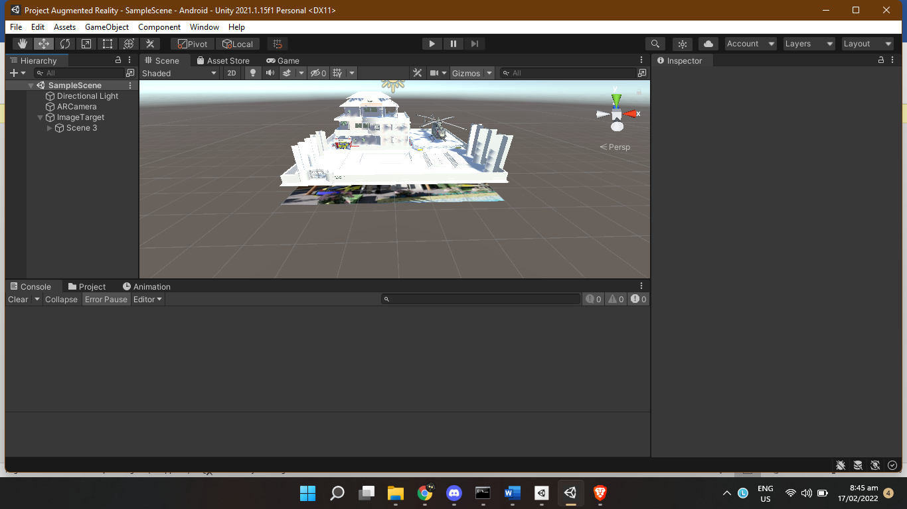

*Figure 3. The Image above is the setting up of the 3d Model of the Target Image (luxury house bangladesh)*

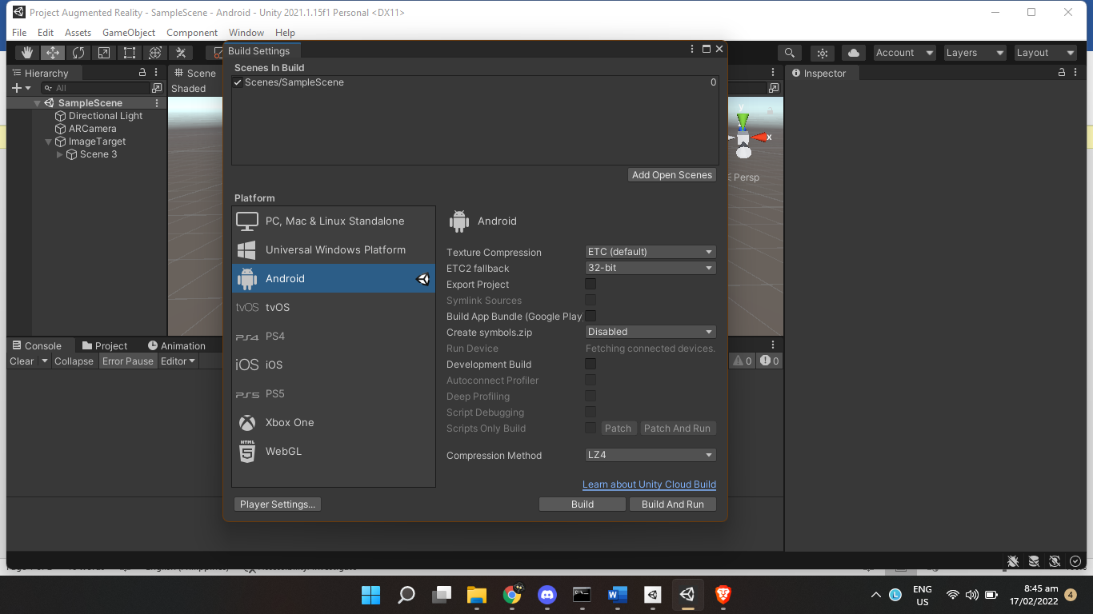

*Figure 4. The Picture shows the step on setting up the build information of the app. In this case we use Android platform to use.*

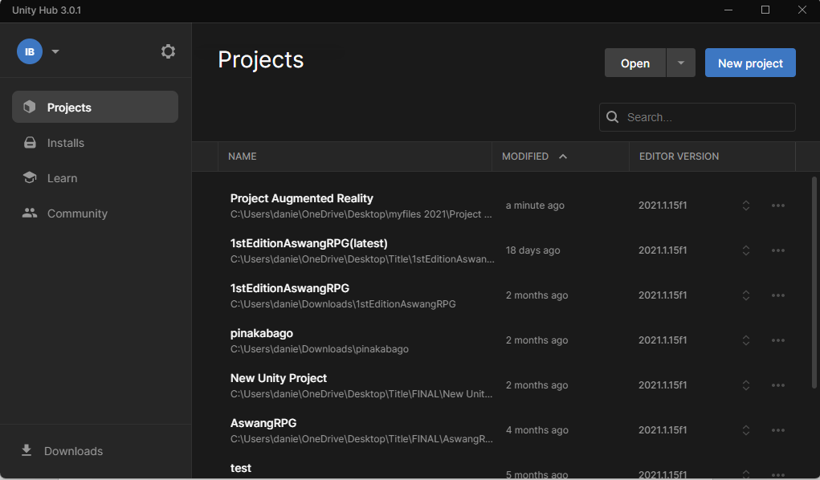

*Figure 5. Since an Android Project needs Unity to be updated to create an Android app. We updated our unity version to the latest to complete the build set up.*

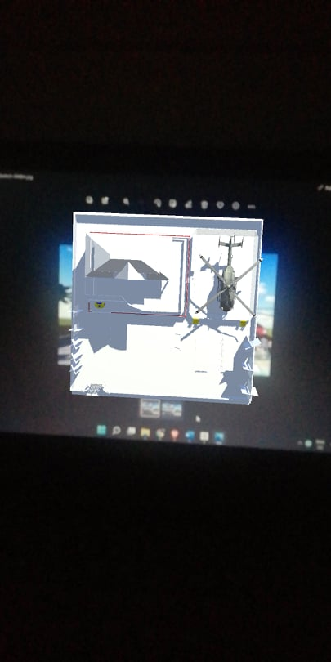

*Figure 6. This figure is a trial and error for the app.*

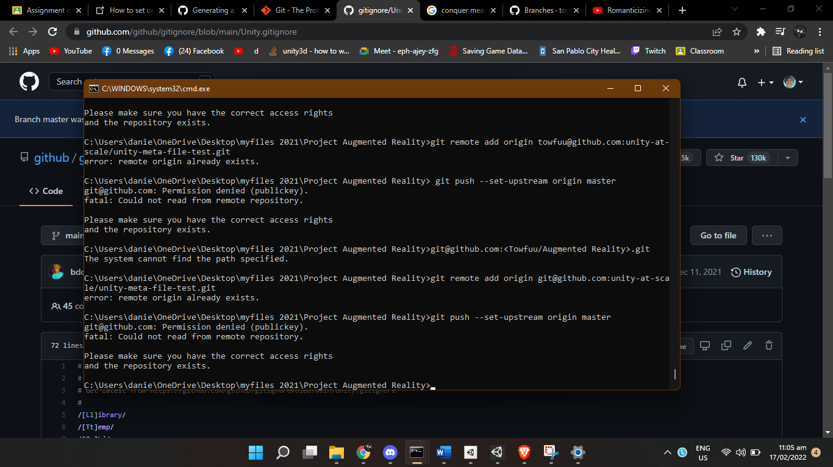

*Figure 7. An attemp to upload the files to github*

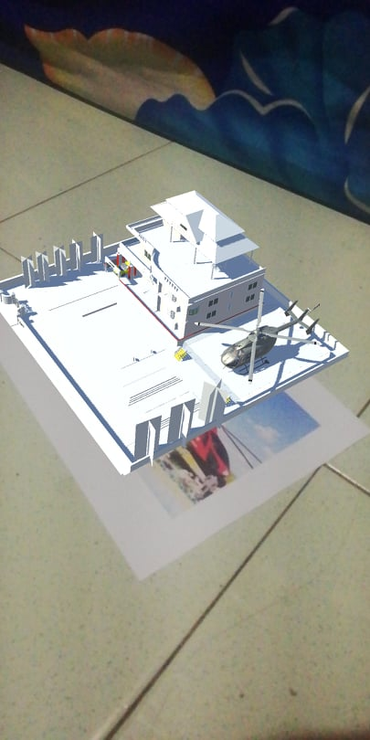

*Figure 8. This Figure above is the final result with a printed image of the house model.*

**The Use of the Application**

We sure did a lot of progress in all aspects of life but not as fast or as revolutionary as what we have in technology, technology evolves really fast leaving other aspects of life behind. As technology evolves, so is all of its uses. More and more uses of technology sprung through the years. Engineering on the other hand, as one of the closest fields to Information Technology, also evolves well, relative to technology. With the rise of virtual reality, more possibilities were opened, re-enacting real-life actions into simulations. Augmented reality having virtual objects on real life environment edges with engineering resulting to a creative and effective approach.

The application we made is an example of one of the uses of augmented reality with engineering. The application projects a 3D virtual model of a luxury house, it may be simple but it is a great example of augmented reality’s potential. With this application as example, we can already visualize its use. This application can be very big in the future as it can be used to present building plans in a detailed way and in real-life size portrayal.